Tools Rental Management
Odoo Module Guide
What the module does inside Odoo — the menus, the screens, the rental workflow, the reports and the setup.
Module version 19.0.2.1.0
by Alphalize Technologies

How to read this guide
This guide explains the Tools Rental Management module from the inside of Odoo — the back office where managers set up tools, take rentals, run reports and configure invoices.
You don't have to read it front to back. Each screen has its own short section telling you what it's for, where to find it in the menus, what you can do there, and a few things worth knowing. Start with the Overview to get the lay of the land, then jump to whatever you need.

What's inside
OVERVIEW
What this module is
The Tools Rental menu
How a rental flows
OPERATIONS
Rental Orders
Confirming and checking out
Discounts and tax
Checking in
Partial returns
Customer rating, Mark Done and Mark Paid
Customer ID Proofs
Customer Ratings
TOOLS, CATEGORIES & PRICING
Rental Tools
Tool Categories
Products and rental tools
Pricing Rules
REPORTING
Dashboard
Tool Availability
Order Reports
Discount Details
Tax Details
Sales Report
CONFIGURATION
Expenses
Expense Categories
Invoice Settings
Printed documents
SETUP & ADMIN
Installing the module
What's created on install
Users and permissions
Running multiple branches

PART 1 · OVERVIEW

What this module is
Tools Rental Management turns Odoo into a complete tool-and-equipment rental system. It keeps a catalogue of your tools and what each one rents for, takes a rental from first enquiry through to a paid invoice, captures photos and signatures along the way, works out late fees and damage charges, and reports on how the business is doing.
Your customers, products and stock all stay in one place. The module then adds its own rental orders, tools, pricing rules, expenses, dashboards and printed documents on top.

The Tools Rental menu
Everything lives under a single top-level Tools Rental menu, grouped into five sections:
Tools Rental
Operations
Rental Orders — your active (checked-out) orders
All Orders — every order, any status
Customer ID Proofs — scanned customer ID photos
Customer Ratings — how customers have been to deal with
Tools & Equipment
Rental Tools (Internal) — the tool inventory (managers)
Categories — the tool category dashboard
Pricing
Pricing Rules — the price list
Pricing Templates — reusable sets of prices
Reporting
Dashboard — orders graph / pivot
Tool Availability — stock and status of every tool
Order Reports — order analytics
Discount Details — discounts given
Tax Details — tax collected
Sales Report — revenue analytics
Expenses — running costs
Configuration
Expense Categories — the list of expense types
Invoice Settings — invoice branding & terms

Good to know
- What you see depends on your role — a Rental User sees the day-to-day screens; a Rental Manager also sees the internal tool inventory, pricing and configuration.

How a rental flows
Every rental order moves along a clear track, and the buttons on the order change to offer only the next sensible step:
- Draft — the order is being built: pick the customer, add tools, set the rental period.
- Confirmed — the booking is locked in and a customer ID is generated; the tools are reserved.
- Checked Out — the tools have been handed over (with condition, photos, ID and signature captured); each tool is marked Rented.
- Checked In — the tools have come back; condition is recorded, late fees and damage are settled, and the tools are free again.
- Done → Invoiced — the customer is rated, the order is wrapped up and an invoice is raised.
- Cancelled — an order backed out before completion; any reserved tools are released.

Good to know
- Each step writes a line to the order's Timesheet / Log, so there's always an audit trail of who did what and when.
- Most of the work at each step happens through a guided wizard (check-out, check-in, discount, tax, rating) — described in the Operations section.

PART 2 · OPERATIONS

Rental Orders

What it's for
The rental order is the heart of the module — one document per rental that holds the customer, the tools, the dates, the money and the full history. The order list is colour-coded by status (late in red, done in green, checked-out in blue, cancelled in grey) so you can read the board at a glance.

Where to find it
Tools Rental → Operations → Rental Orders shows the orders that are currently out; Tools Rental → Operations → All Orders shows every order whatever its status.

What you can do
- Open an order to see its workflow buttons along the top and its details below — customer, rental period, and the Rental Lines (each tool with its price, duration, tax and total).
- Use the tabs on the order — Rental Lines, Timesheet/Log, Check-Out Details, Check-In Details, Discount Details, Tool Photos, Notes & Terms — to dig into any part.
- Read the financial summary (subtotal, tax, late fees, damage charges, discount, amount due) at the foot of the order.
- Filter and group the list by status, customer, tool, period or month; quick filters pick out late returns and today's check-outs and returns.
- Switch to the Calendar view to see rentals across their periods, or the Pivot and Graph views for analysis.

Good to know
- The order number looks like RNT/2026/00001 and is generated automatically; the customer gets an ID like CUS/0001 when the order is confirmed.
- You add tools by picking a product — the matching rental tool is found (or created) behind the scenes, and the price fills in from its pricing rule.
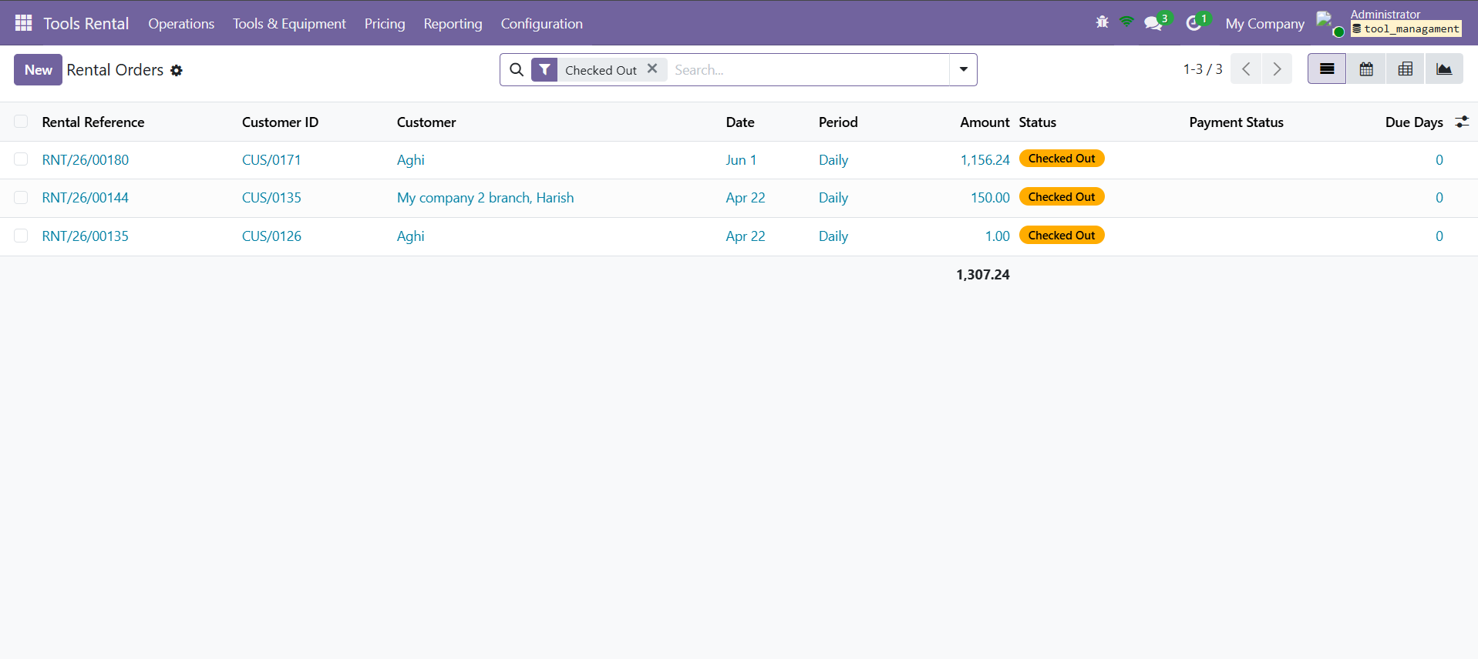
Rental Orders — the active (checked-out) orders, colour-coded by status.
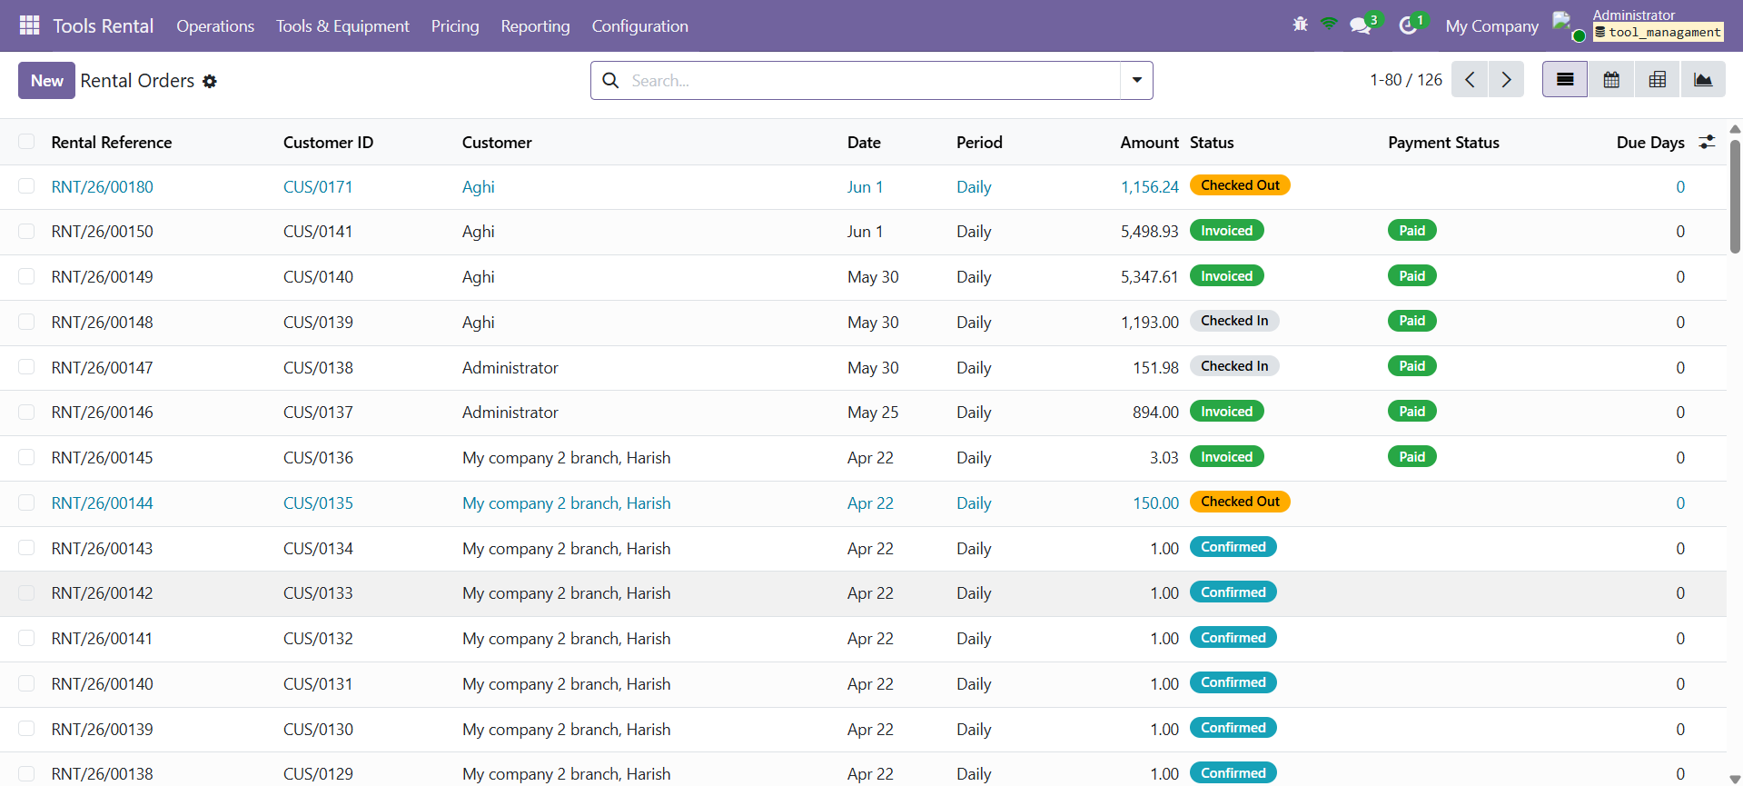
All Orders — every rental order, whatever its status.

Confirming and checking out

What it's for
Once an order is confirmed, checking out is how the tools leave the shop. It opens a wizard that captures everything you need at the counter so there's proof of what went out and in what state.

Where to find it
On a confirmed order, press Check-Out (the workflow button on the order).

What you can do
- Set each tool's Condition (Excellent, Good, Fair, Poor or Damaged) and optionally snap a photo of it.
- If you're taking money up front, enter an Advance and the payment method (Cash, Card, Bank or Credit); for cash you can record what was handed over to show the change.
- Capture the customer's ID Proof — front required, back optional.
- Take the customer's signature, then confirm. The order moves to Checked Out and each tool is marked Rented.

Good to know
- The ID photos and signature are saved against the customer too, so they're on file for next time.
- The condition you record now is the baseline the tools are compared against when they come back.

Discounts and tax

What it's for
While an order is checked out you can take money off or add tax before the final bill. Both open their own wizard.

Where to find it
On a checked-out order, use the Discount and Tax workflow buttons.

What you can do
- Discount asks for authorisation first — the authoriser's name, signature and photo — then lets you give a Total discount across the order or a Per-Product discount on each line, as a percentage or a fixed amount.
- Tax lets you apply one Total Tax percentage to everything, or a Per-Product percentage on each line; the tax amount works itself out.
- Both write a line to the Timesheet/Log recording what was applied and, for discounts, who authorised it.

Good to know
- A discount can be changed or removed later from the same button.
- Tax here is always a percentage, never a fixed amount.

Checking in

What it's for
Checking in is how the tools come back and the bill is settled. The wizard walks through each tool's return condition and works out anything extra that's owed.

Where to find it
On a checked-out order, press Check-In.

What you can do
- Record each tool's return Condition and optionally a check-in photo.
- Late fees fill in automatically — the wizard counts the extra days beyond the planned return and multiplies by the tool's late fee per day.
- Add a Damage Note and Damage Charge for anything that came back the worse for wear.
- Review the payment summary — rental, tax, late fees, damage, discount and any advance — down to the Amount Due, then pick the payment method.
- Take the customer's signature and the staff (authority) signature with the signer's name, then confirm. The order moves to Checked In and the tools become available again.

Good to know
- If an advance was taken at checkout, you can tick to return it as part of the settlement.
- An overdue return shows a late warning and the number of extra days.

Partial returns

What it's for
Sometimes a customer brings back only part of an order and keeps the rest longer. The check-in wizard handles that without closing the whole order.

Where to find it
Start a check-in as usual on a checked-out order.

What you can do
- Set how many of each tool are coming back now (or remove the lines that aren't returning yet).
- The confirm button becomes Save (Partial Return); save it.
- The returned tools are recorded and freed; the rest stay out and the order remains Checked Out.
- When the remaining tools return, check in again — the ones already back are left out automatically.

Good to know
- A partially returned order can produce its own Partial Return Invoice for what's already come back.
- Each partial return is noted in the Timesheet/Log (“Partial return: Tool x qty”).

Customer rating, Mark Done and Mark Paid

What it's for
After a full check-in the order is wrapped up — you rate the customer, mark the order done, and record payment when the money is in.

Where to find it
On a checked-in order, use the rating prompt and the Mark Done / Mark Paid buttons.

What you can do
- Give the customer a rating — Perfect, Very Good, Good, Fair or Poor (or Skip) — which is saved on the order and on the customer's record.
- Mark Done finishes the order and moves it to Invoiced.
- If anything is still owed, the order shows Unpaid with a Mark Paid button; tap it once paid. Credit days are tracked for orders paid later.

Good to know
- The rating is required before an order can be marked done, so customer feedback never gets skipped by accident.
- Ratings build up over time into the Customer Ratings screen.

Customer ID Proofs

What it's for
This screen gathers the scanned ID documents captured during check-out, so you can see at a glance which customers have ID on file.

Where to find it
Tools Rental → Operations → Customer ID Proofs.

What you can do
- Browse customers with their front and back ID images.
- Open a customer to view or update the stored ID.

Good to know
- IDs captured at checkout are saved here against the customer automatically.

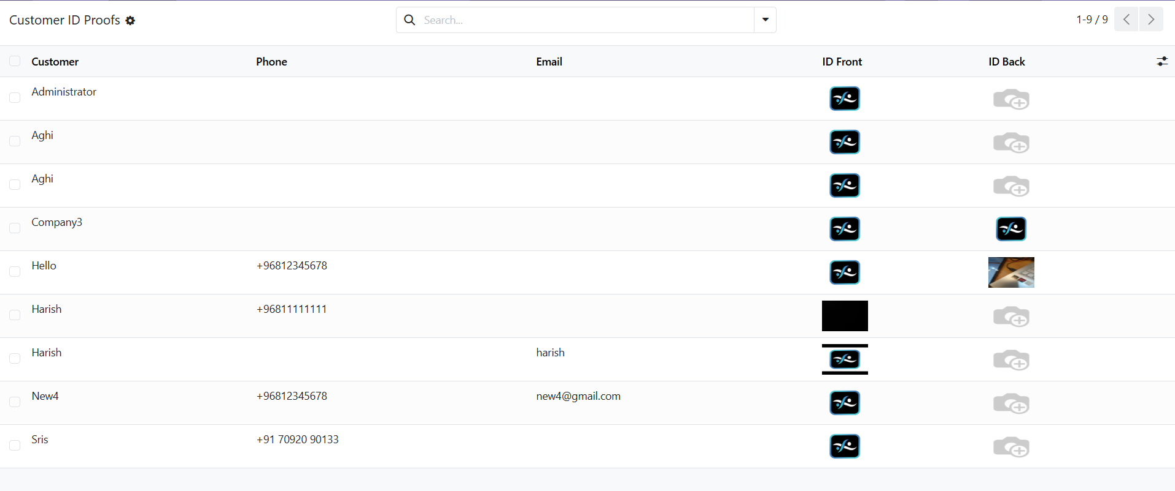
Customer ID Proofs — each customer's stored front and back ID images.

Customer Ratings

What it's for
Customer Ratings is the list of how customers have been to deal with — a quick reputation built from the ratings staff give at check-in.

Where to find it
Tools Rental → Operations → Customer Ratings.

What you can do
- See each rated customer with their rating, the date it was last set and any notes.
- Use it to spot trusted regulars and customers to take more care with.

Good to know
- The same rating shows on the customer's contact record, so it travels with them across the system.

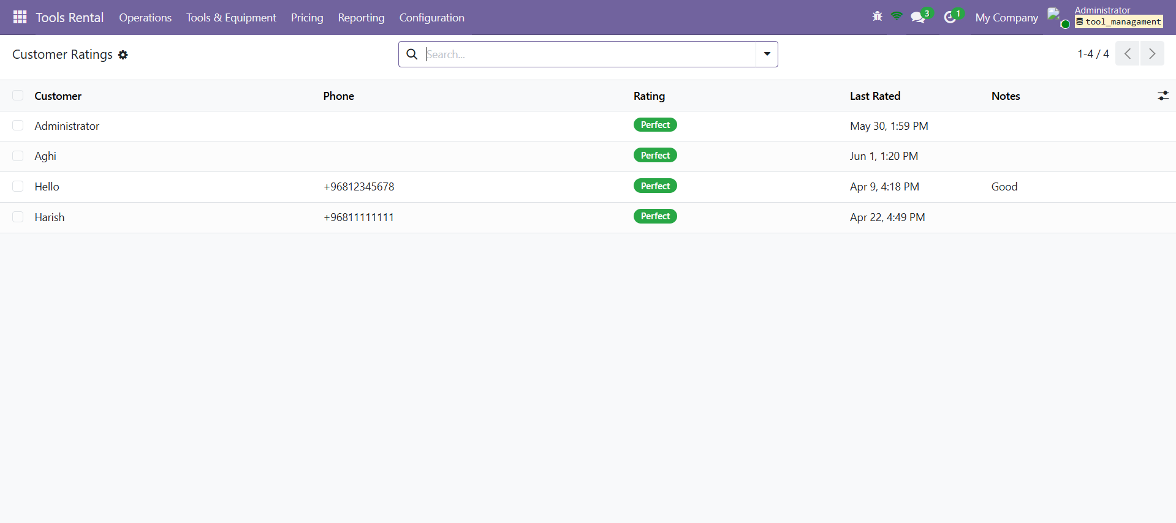
Customer Ratings — how each customer has been to deal with.

PART 3 · TOOLS, CATEGORIES & PRICING

Rental Tools

What it's for
The rental tool is the master record for each piece of equipment you rent. It holds the tool's name, code, category, photo, serial number, barcode, quantity and specifications, and tracks its status and rental history.

Where to find it
Tools Rental → Tools & Equipment → Rental Tools (managers).

What you can do
- Browse tools as cards (kanban) with their photo, status badge and rate, or as a sortable list; open one to edit its details.
- Watch each tool's status — Available, Rented, Maintenance or Retired — and set it to Maintenance or Retired when needed.
- See a tool's rental count and revenue, and its embedded pricing rules.

Good to know
- A tool's available quantity is worked out for you from how many are currently checked out.
- Tools that are Retired or in Maintenance can't be added to new rentals.

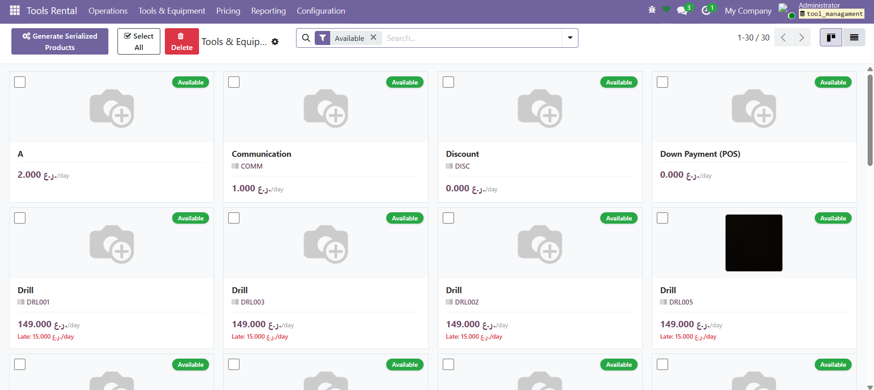
Tools & Equipment — the tool catalogue, with status badges and day rates.

Tool Categories

What it's for
Categories group your tools — Power Tools, Hand Tools, Heavy Equipment and so on — and can be nested into sub-categories. They become the filters you see across the tool and pricing screens.

Where to find it
Tools Rental → Tools & Equipment → Categories.

What you can do
- Browse categories with their code, tool count and sub-category count.
- Open one to rename it, give it a code, set a parent, or jump to the tools inside it.

Good to know
- The module ships with seven ready-made categories (Power Tools, Hand Tools, Heavy Equipment, Measuring Instruments, Safety Equipment, Garden & Landscaping, Cleaning Equipment) — use them as-is or add your own.

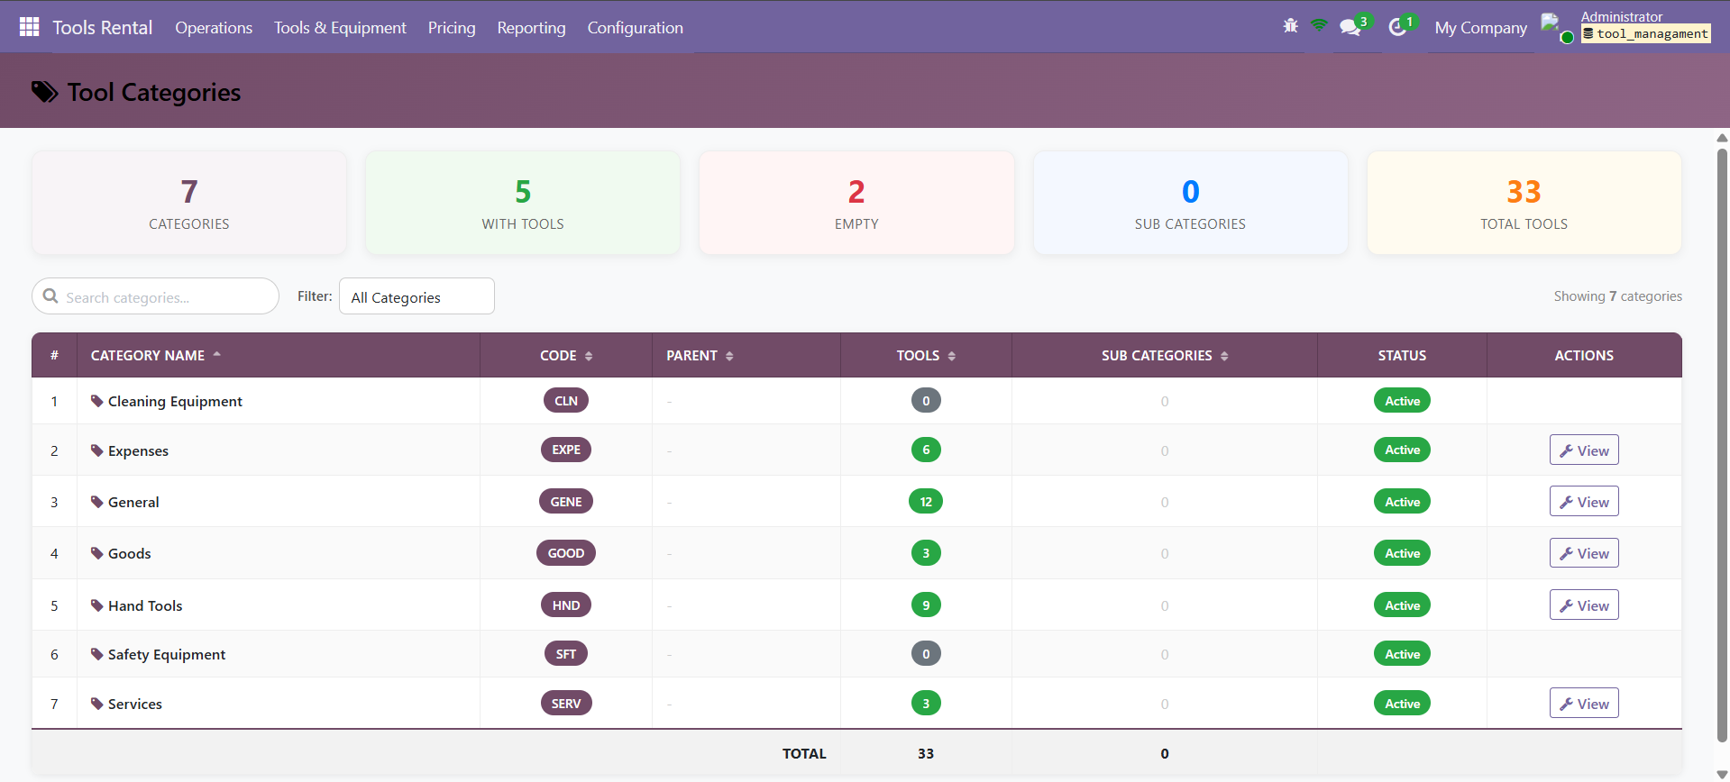
Tool Categories — the category dashboard with a tool count for each.

Products and rental tools

What it's for
Rental tools and Odoo products are two sides of the same item. Marking a product as a rental tool links it to a rental tool record and keeps the two in step, so the item is both stockable in Odoo and rentable here.

Where to find it
On any product form (Inventory / Sales), plus the bulk actions in the product list.

What you can do
- Tick Is Rental Tool on a product, set its rental category and late fee, and it syncs to a matching rental tool.
- Use the bulk actions to mark many products for rental at once, or sync all products to tools.
- Use Generate Serialized Products to create one product per serial number (e.g. DRL-001, DRL-002, …) in one go — handy for a batch of identical tools.

Good to know
- A daily background job re-syncs rental products to tools, so the two never drift apart.
- Each serial becomes its own trackable unit, so you always know which exact tool went out.

Pricing Rules

What it's for
Pricing Rules are the price list — they decide what each tool costs to rent and the late fee if it comes back late. A rule can be tied to one tool, to a whole category, and to a billing period.

Where to find it
Tools Rental → Pricing → Pricing Rules.

What you can do
- Read each rule across: product, units, category, period type (Day, Week, Month or Fixed), price, late fee per day and the duration range it applies to.
- Edit prices inline in the list, or open a rule to set its period, price, late fee and minimum/maximum duration.

Good to know
- The late fee per day here is exactly what the check-in wizard uses to work out late charges.
- A tool with no pricing rule shows no rate and can't be rented until one is set.

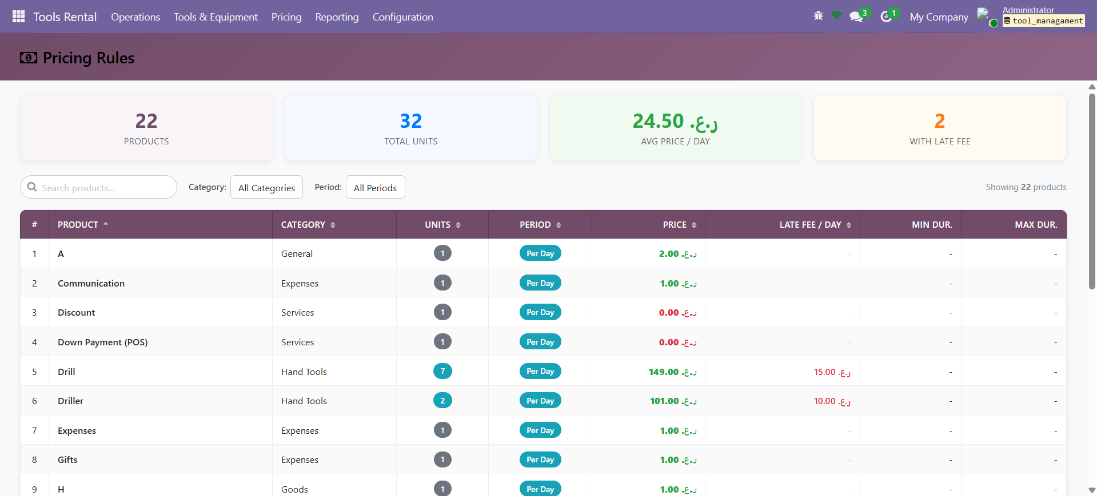
Pricing Rules — the price list, with day rates and late fees.

PART 4 · REPORTING

Dashboard

What it's for
The Dashboard is the quick pulse of the business — your rental orders plotted and summarised so you can see volume and revenue trends.

Where to find it
Tools Rental → Reporting → Dashboard.

What you can do
- Read the headline numbers and the orders graph/pivot.
- Group and pivot by date and billing period to spot busy and quiet spells.

Good to know
- It's the at-a-glance view; the other reports below go deeper into specific angles.

Tool Availability

What it's for
Tool Availability shows the stock and status of every tool in one place — how many you have, how many are free, how many are out, plus rentals and revenue per tool.

Where to find it
Tools Rental → Reporting → Tool Availability.

What you can do
- Read the summary cards (total tools, available, checked out, total rentals, total revenue) and the per-tool table below.
- Filter by status or category, and group by category or state.
- Export the whole list to Excel or PDF.

Good to know
- Run it first thing to see what's free before promising a tool to a customer.
- The numbers keep themselves up to date as tools go out and come back.

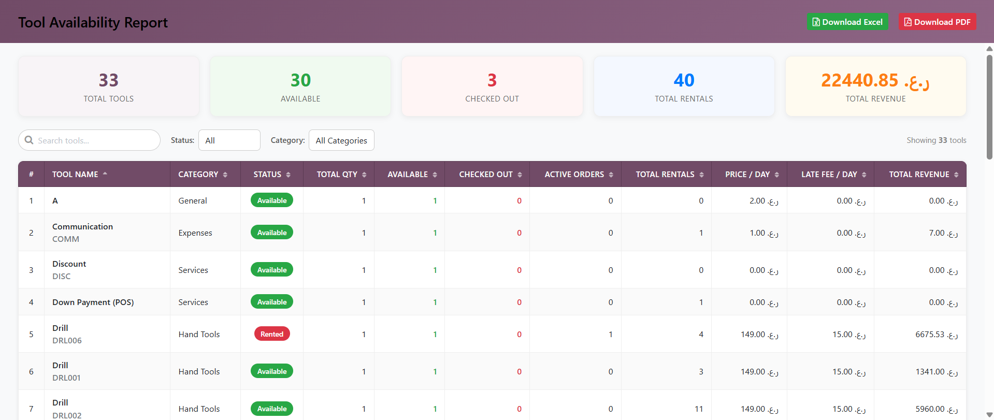
Tool Availability — stock and status of every tool, with totals up top.

Order Reports

What it's for
Order Reports is the line-by-line analytics behind the orders — every order with its customer, status and amount, plus headline totals.

Where to find it
Tools Rental → Reporting → Order Reports.

What you can do
- Search and filter the orders, and read the KPIs (total orders, active rentals, revenue, late returns).

Good to know
- Where the Dashboard summarises, Order Reports lets you drill into individual orders.

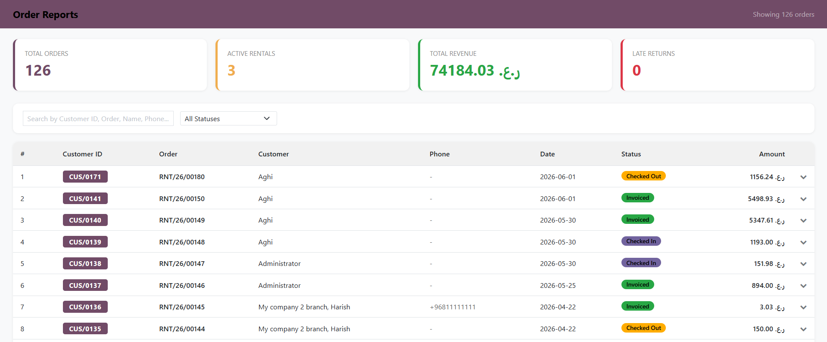
Order Reports — every order with its status and amount, plus headline totals.

Discount Details

What it's for
Discount Details lists every order where a discount was given, with the totals and who authorised each one — so giveaways stay accountable.

Where to find it
Tools Rental → Reporting → Discount Details.

What you can do
- Read the summary (discounted orders, total discount, average, revenue after discount) and the per-order breakdown.
- See the customer, the order, who authorised it, the amount off and the status.

Good to know
- It answers “how much are we discounting, and who's giving it away?” at a glance.

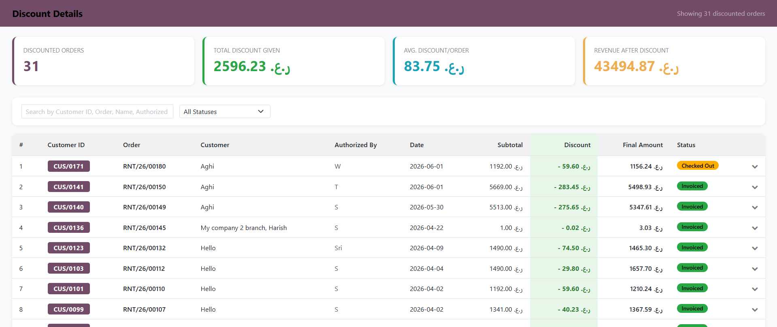
Discount Details — discounts given, with who authorised each one.

Tax Details

What it's for
Tax Details is the companion to Discount Details, but for tax — the taxed orders, the tax collected and a per-order breakdown.

Where to find it
Tools Rental → Reporting → Tax Details.

What you can do
- Read the totals (taxed orders, total tax, average, revenue including tax) and each order's subtotal, tax and total.

Good to know
- It's the one place to see how much tax you've collected over a run of orders.

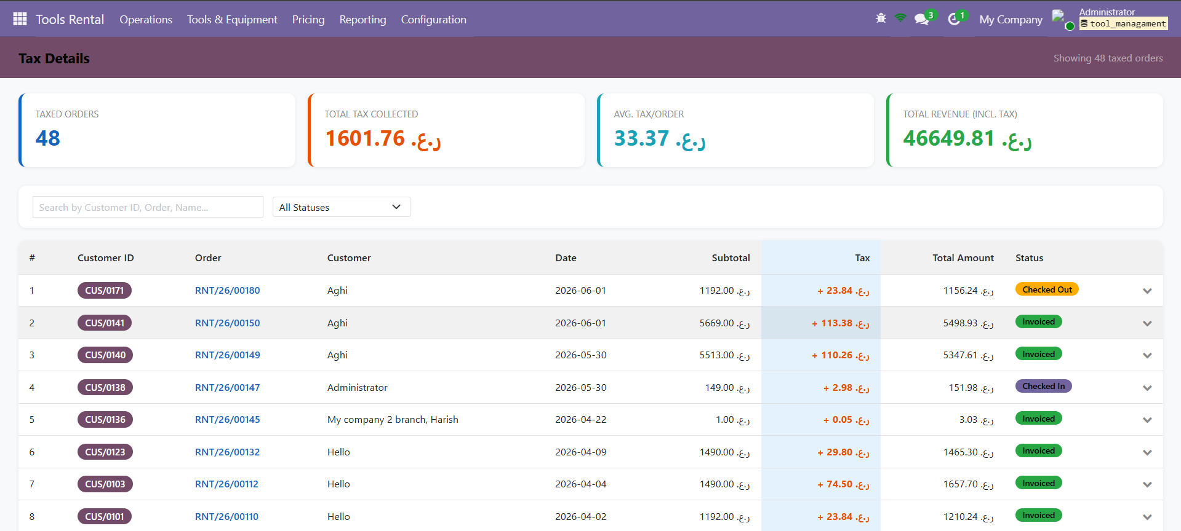
Tax Details — tax collected across your orders.

Sales Report

What it's for
Sales Report is the revenue scoreboard — total revenue and orders, average order value, tax, damage, late fees and discounts, plus your best customers and best-earning tools.

Where to find it
Tools Rental → Reporting → Sales Report.

What you can do
- Pick a period (today, week, month, year, all time or a custom range) and a payment method (cash, card, bank, credit).
- Read the KPIs and the Top Customers and Top Tools tables.

Good to know
- It mirrors the app's Sales Report, so the office and the counter see the same figures.

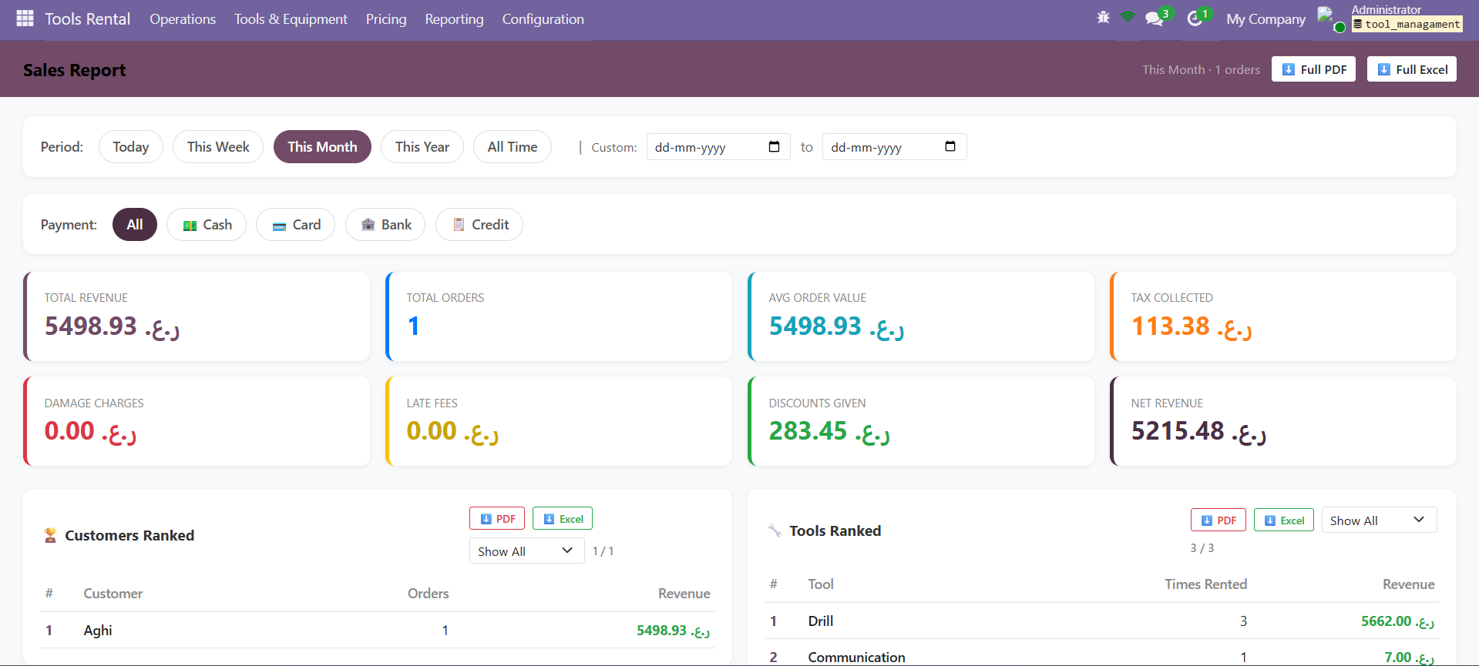
Sales Report — revenue, best customers and best-earning tools.

Expenses

What it's for
Expenses records what the business spends — fuel, repairs, supplies and the like — and moves each one through Draft, Submitted, Approved, Paid or Refused. A split tool lets you break a big expense into several.

Where to find it
Tools Rental → Configuration → Expenses.

What you can do
- Add an expense with its category, amount, tax, payment mode, manager and an optional receipt photo.
- Submit it for approval; managers approve, pay or refuse it.
- Use the split tool to divide one expense across several categories, rentals or employees.

Good to know
- Keeping expenses current is what makes the profit figures in the reports trustworthy.
- Each expense can be tied to a specific rental order when it relates to one.

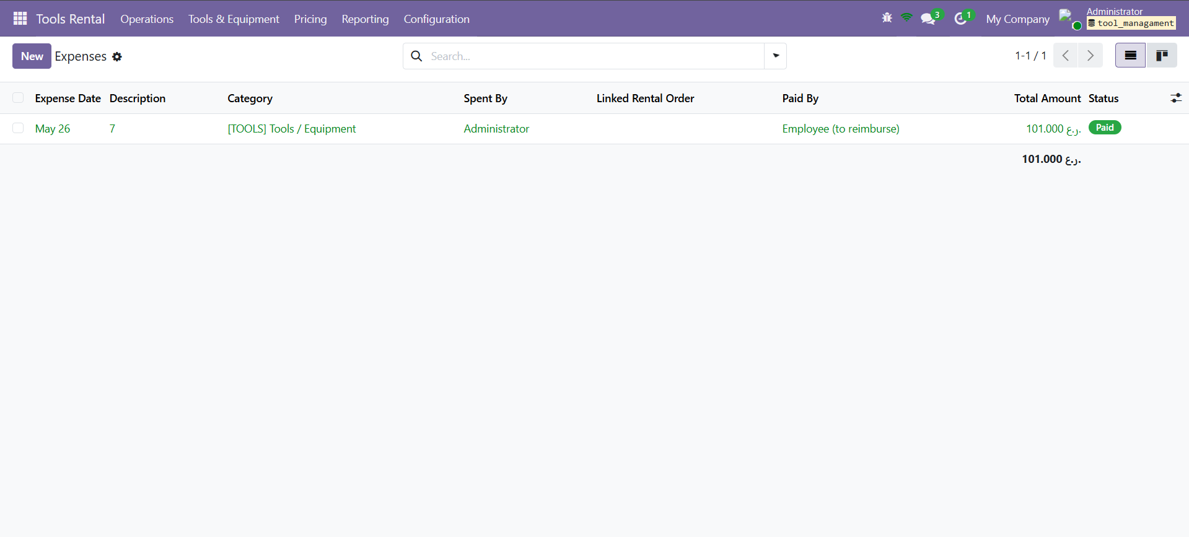
Expenses — running costs with their status.

PART 5 · CONFIGURATION

Expense Categories

What it's for
Expense Categories are the list of expense types, each with a default cost and tax rate and a short guideline, so logging an expense is quick and consistent.

Where to find it
Tools Rental → Configuration → Expense Categories.

What you can do
- Browse and edit the categories and their default amounts and tax.

Good to know
- The module ships with eight ready-made categories — Fuel, Repair / Maintenance, Tools / Equipment, Transport, Office, Food / Travel, Rent / Utilities and Other.

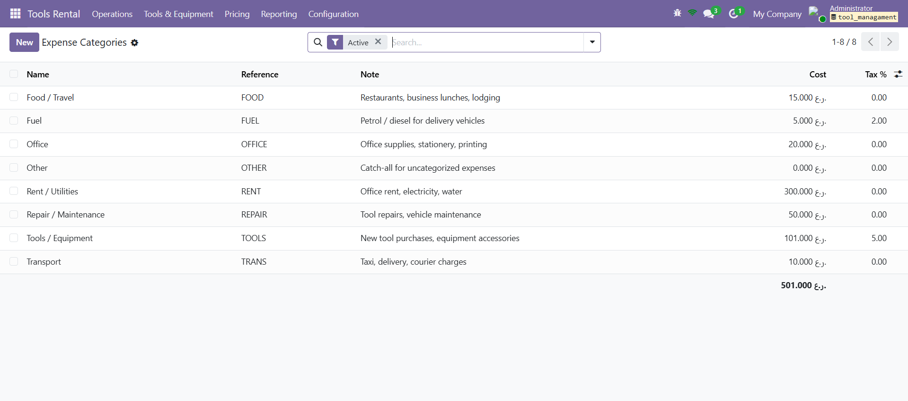
Expense Categories — the expense types with default cost and tax.

Invoice Settings

What it's for
Invoice Settings control how your printed rental documents look — the company name and logos, contact details, headings and the terms & conditions — in both English and Arabic.

Where to find it
Tools Rental → Configuration → Invoice Settings.

What you can do
- Set the company name and sub-name, the centre and right logos, the C.R/address, phone, email and VAT number — with Arabic versions for right-to-left text.
- Set the headings for the Check-Out, Check-In and Partial Return invoices.
- Turn the terms & conditions on and edit them line by line in English and Arabic.

Good to know
- Settings are per company, so each branch can have its own branding.

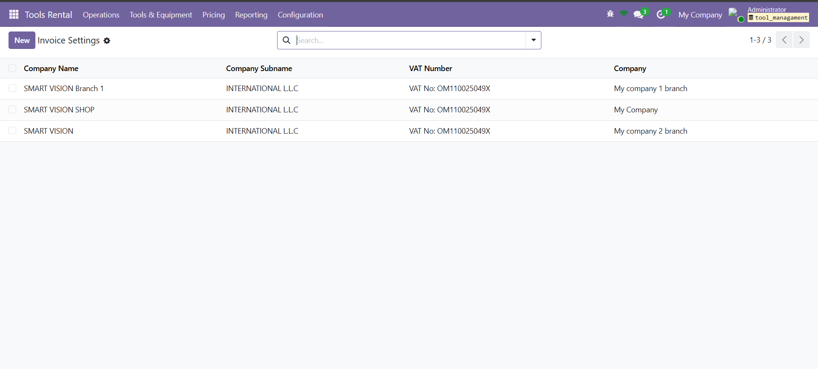
Invoice Settings — per-company invoice branding.

Printed documents

What it's for
The module produces a set of polished PDFs for the rental — an agreement and three invoices — plus the tool report, all using your Invoice Settings branding.

Where to find it
From an order (the print options / print wizard) and from the Tool Availability report.

What you can do
- Rental Agreement — the contract: parties, rental details, the tools table, totals, terms and a signature block.
- Checkout Invoice — the bill at pickup, showing each tool's checkout condition, price and the advance taken.
- Check-In Invoice — the full closing bill: both conditions, extra days, late fees, damage, discount, tax, amount due and a paid/unpaid badge.
- Partial Return Invoice — covers just the tools returned early.
- Tool Availability report — the inventory snapshot as a landscape PDF (or Excel).

Good to know
- Invoices come in A4 and A5 sizes, and can be printed, downloaded as PDF, or sent to the customer over WhatsApp.
- The Check-In Invoice carries up to three signatures — customer, authority and (if a discount was given) the discount authoriser.

PART 6 · SETUP & ADMIN

Installing the module

What it's for
Tools Rental Management installs like any Odoo module and pulls in the standard apps it relies on.

Where to find it
Apps → search “Tools Rental Management” → Install (or upgrade an existing copy).

What you can do
- Make sure the apps it depends on are available — Contacts, Products, Inventory (Stock), Purchase, and the core base and messaging features.
- After installing, the Tools Rental menu appears for users in the rental groups.

Good to know
- It's published by Alphalize Technologies under the LGPL-3 licence; this guide covers version 19.0.2.1.0.

What's created on install

What it's for
Installing sets up sensible defaults so you can start straight away.

Where to find it
Created automatically the first time the module is installed.

What you can do
- Numbering sequences — rentals numbered RNT/<year>/00001 and customers CUS/0001.
- Seven tool categories and eight expense categories, ready to use or rename.
- A daily background job that keeps rental products and rental tools in sync.

Good to know
- You can change or add to any of these defaults at any time — they're just a starting point.

Users and permissions

What it's for
The module defines two roles so staff only see what they should.

Where to find it
Settings → Users — assign each user a rental role.

What you can do
- Rental User — the day-to-day role: read everything, and create and edit rental orders and expenses, but not delete the core records.
- Rental Manager — full control: manage tools, pricing and templates, approve and pay expenses, edit invoice settings and run the product-to-tool sync.

Good to know
- The internal tool inventory, pricing and configuration menus are aimed at managers; users work mostly in Operations.

Running multiple branches

What it's for
The module is multi-company aware, so a business with several branches keeps each branch's data separate.

Where to find it
Set the user's allowed companies in Settings → Users; the active company selector switches branch.

What you can do
- Tools, orders, pricing and timesheets each belong to a company and are filtered to the branches a user is allowed to see.
- Invoice Settings are per company, so each branch prints its own branding.

Good to know
- This matches the branch picker in the mobile app — staff choose the branch they're working from and see only its data.

